Lecture 02

**NW3-DNS-Resolv-conf**

* **$ /etc/reslv.cnfg --> if you want to ping a website by name**
* 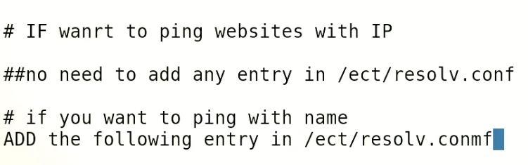
* 8.8.8.8 --> its public ip from google working as DNS
* If you want to ping IP of a website?
  + No need to add any entry in /etc/resolv.conf
* Tip:-
* Use $ nmtui for IP (static in most cases) configuration
* **Check Ip with these commands**
* $ ip r l
* $ ip a
* $ ip a list
* **$ ifconfig is an old command**
* $ route add defalt gw <gw> --> to add a default GW
* $ route –n --> gives gateway information
* 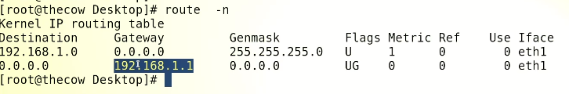
* *there can be onlty 1 GW as default GW
* To remove a GW
* $ route del default gw <gw>
* 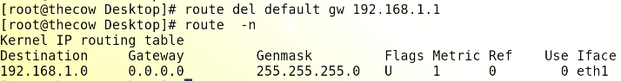
* *multiple gateways could possibly available but only 1 gateway is used to access the traffic at a time

**DNS**

**Domain Name Service**

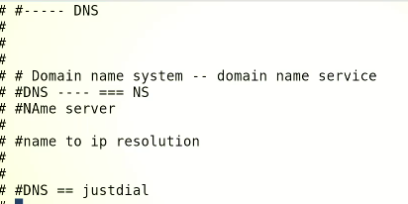

* 1.7 billion approx. web sites use IP addresses

resolv.cnfg

* Browser -🡪 web address 🡪 /etc/resolv.cnfg – to grab required IP
* 
* In Windows
* 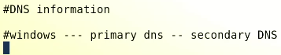
* 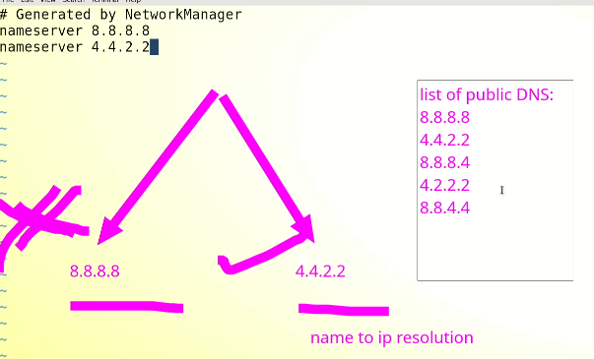
* 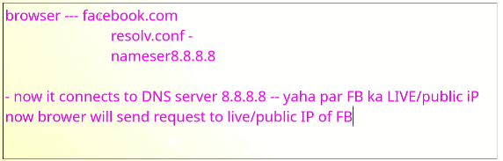
* Task
* 
 